A CRM APPLICATION FOR THECHAISHOP&CO

Team Member
ARTHI . R
DURGA . V
MADHUMITHA V
SARASU . C
UMAMAGESHWARI . M

User Story:
As a sales representative at TheChaiShop&Co, I want to efficiently manage customer relationships and streamline sales processes using our CRM application.
I want to easily access and update employer details, as well as distinguish between online and offline customer records using record types, allowing for personalized interactions.
Additionally, I need the application to automate sales calculations, such as order quantity and total bill amount, to ensure accurate and efficient transactions.
Moreover, I require the ability to generate insightful reports and dashboards to summarize and analyze sales data effectively, aiding in decision-making and strategy development.
Lastly, I would like the application to automate email notifications to customers on their birthdays, informing them of special offers tailored to celebrate their special day, enhancing customer engagement and loyalty.

- Project Development Phase:

Project Flow
Milestone 1 : Creation of developer account Milestone 2 : Object Creation
Milestone 3 : Tabs
Milestone 4 : The Lightning App
Milestone 5 : Global Picklist
Milestone 6 : Fields and Relationships Milestone 7 : Creation of Page Layout Milestone 8 : Creation of Record Types Milestone 9 : Validation rules
Milestone 10 : Email Templates Milestone 11 : Flows
Milestone 12 : Reports and Dashboards Milestone 13 : Conclusion

Milestone 2 - Objects

  - In your Salesforce org, click gear icon on the top left and select Setup to open Setup.

Activity 1 : Employer Account Object

Activity 2 : Customer Account Object

Activity 3 : Enterprise Account Object

Milestone 3 - Tabs
Activity 1 : Custom tabs creation

Milestone 4 - The Lightning App

Activity 1 : Create a lightning app

- Fill the app name in app details and branding as follow App Name : TheChaiShop&Co
Developer Name : Auto Populates
Add image optional (if you want to give any image you can otherwise not mandatory) - Add Primary color Hex or leave it to default.
Then click Next.

- In App options
Navigation style : Standard navigation Setup experience : setup
Supporters form factors : Desktop and phone Then click Next

- In Utility items
Utility Bar alignment : Default Then click Next.

- Navigation items
Select the created Custom Objects and required standard objects
  - Customer Accounts Employer Accounts Enterprise Accounts Reports Dashboards

- To Add User Profiles : System Administrator

- Click Save & Finish.

Milestone 6 : Fields & Relationships

Activity 1 : Create Custom fields for Employer Account

- Data Type : Text
Field Label: First Name Field Name : Auto Populates Length : 25
Required : Check the box
Click on Next → Next → Save and new.

- Repeat the Same steps for remaining fields

  - Data Type : Text
Field Label: Last Name
Field Name : Auto Populates Length : 25
Required : Check the box
Click on Next → Next → Save and new.

  - Data Type : PickList
Field Label: Gender
Values : Use Global Picklist value set and select Gender from the dropdown menu.
Field Name : Auto Populates. Required : Check the box
Click on Next → Next → Save and new.

  - Data Type : Phone
Field Label : Phone Number Field Name : Auto Populates Required : Check the box
Click on Next → Next → Save and new.

  - Data Type : Email Field Label : Email ID
Field Name : Auto Populates Required : Check the box
Click on Next → Next → Save and new.

  - Data Type : Date
Field Label : Date of Birth Field Name : Auto Populates Required : check the box
Click on Next → Next → Save and new.

  - Data Type : Text
Field Label : Aadhar Number Field Name : Auto Populates Length : 12
Click on Next → Next → Save and new.

  - Data Type : Text
Field Label : PAN Details Field Name : PAN_Details
Length : 10
Click on Next → Next → Save and new.

  - Data Type : Picklist
Field Label : Designation Field Name : Auto Populates
Value : Enter value, with each value separated by a new line.
Manager
Finance and Accounting Kitchen Staff
Cashier Servers
Click on Next → Next → Save and new.

  - Data Type : Currency
Field Label : Salary
Field Name : Auto Populates
Click on Next → Next → Save.

Activity 2: Create Custom fields for Customer Account
- Data Type : Text
Field Label: First Name Field Name : Auto Populates Length : 25
Required : Check the box
Click on Next → Next → Save and new.

- Data Type : Text
Field Label: Last Name
Field Name : Auto Populates Length : 25
Required : Check the box
Click on Next → Next → Save and new.

- Data Type : PickList
Field Label: Gender
Values : Use Global Picklist value set and select Gender from the dropdown menu.
Field Name : Auto Populates. Required : Check the box
Click on Next → Next → Save and new.

- Data Type : Phone
Field Label : Phone Number Field Name : Auto Populates Required : Check the box
Click on Next → Next → Save and new.

- Data Type : Date
Field Label : Date of Birth Field Name : Auto Populates Required : check the box
Click on Next → Next → Save and new.

- Data Type : Formula
Field Label : Date of Birthday is today ? Field Name : Auto Populates
Formula Return : Checkbox
Formula :
IF( AND(
DAY( TODAY() ) = DAY( Date_of_Birth c ) , MONTH ( TODAY()) = MONTH( Date_of_Birth c )), TRUE,
FALSE)
Click on Next → Next → Save and new.

- Data Type : Email Field Label : Email ID
Field Name : Auto Populates Required : Check the box
Click on Next → Next → Save and new.

- Date Type : Text Field Label : Address
Field Name : Auto Populates
Length : 125
Click on Next → Next → Save and new.

- Date Type : Multi Select Picklist
Field Label : Type of Items
Values : Use Global Picklist value set and select Type of Items from the dropdown menu. Field Name : Auto Populates.
Required : Check the box
Click on Next → Next → Save and new.

- Date Type : Multi Select Picklist
Field Label : Products purchased
Values : Use Global Picklist value set and select Items from the dropdown menu.
Field Name : Auto Populates. Required : Check the box
Click on Next → Next → Save and new.

- Date Type : Multi Select Picklist
Field Label : Chai
Value : Enter value, with each value separated by a new line.
TheChaiShop&Co Special Tea Single Tea
Masala Tea Lemon Tea Ginger Tea Green Tea Sugar Free Tea
Click on Next → Next → Save and new.

- Data Type : Picklist
Field Label : Payment Mode
Values : Use Global Picklist value set and select Payment Mode from the dropdown menu. Field Name : Auto Populates.
Required : Check the box
Click on Next → Next → Save and new.

- Data Type : Lookup Relationship Related To : Employer Account Field Label : Associated Employer Field Name : Auto Populates
Click on Next → Next → Save and new.

- Data Type : Formula
Field Label : Order Quantity Field Name : Auto Populates Formula Return : Number

Enter Formula = Quantity (Number) =
IF(INCLUDES( Products_Purchased c , "Platinum Tea Powder"), 1, 0 ) +
IF(INCLUDES( Products_Purchased c , "Double Delight Tea Powder"), 1, 0 ) + IF( INCLUDES( Products_Purchased c , "Super Dust Tea Powder") , 1, 0) +
IF(INCLUDES( Products_Purchased c , "Osmania Biscuits (Value Pack)"), 1, 0 ) + IF(INCLUDES( Products_Purchased c , "Osmania Biscuits (Premium Pack)"), 1, 0 ) + IF( INCLUDES( Products_Purchased c , "Dry Fruit Biscuits") , 1, 0) +
IF(INCLUDES( Products_Purchased c , "Fruit Biscuits"), 1, 0 ) + IF(INCLUDES( Products_Purchased c , "Salt Biscuits"), 1, 0 ) + IF(INCLUDES( Products_Purchased c , "Multigrain Biscuits"), 1, 0 ) + IF(INCLUDES( Products_Purchased c , "Ragi Biscuits"), 1, 0 ) +
IF( INCLUDES( Products_Purchased c ,"Double Choco chip Cookies") , 1, 0) + IF(INCLUDES( Products_Purchased c , "Butter Almond Cookies"), 1, 0 ) + IF(INCLUDES( Products_Purchased c , "Melting Moments Cookies"), 1, 0 ) + IF( INCLUDES( Products_Purchased c , "Honey Oats Cookies") , 1, 0) + IF(INCLUDES( Products_Purchased c , "Delight Box"), 1, 0 ) +
IF(INCLUDES( Products_Purchased c , "Signature Box"), 1, 0 ) + IF( INCLUDES( Products_Purchased c , "Assorted Pack") , 1, 0) + IF(INCLUDES( Chai c , "TheChaiShop&Co Special Tea"), 1, 0) + IF(INCLUDES( Chai c , "Single Tea"), 1, 0) +
IF(INCLUDES( Chai c , "Masala Tea"), 1, 0) +
IF(INCLUDES( Chai c , "Lemon Tea"), 1, 0) + IF(INCLUDES( Chai c , "Ginger Tea"), 1, 0) + IF(INCLUDES( Chai c , "Green Tea"), 1, 0) + IF(INCLUDES( Chai c , "Sugar Free Tea"), 1, 0)
Click on Next → Next → Save and new.

- Data Type : Formula
Field Label : Total Bill
Field Name : Auto Populates Formula Return : Number
Enter Formula = Quantity (Number) =
IF(INCLUDES( Products_Purchased c , "Platinum Tea Powder"), 175, 0 ) + IF(INCLUDES( Products_Purchased c , "Double Delight Tea Powder"), 150, 0 ) + IF( INCLUDES( Products_Purchased c , "Super Dust Tea Powder") , 125, 0) + IF(INCLUDES( Products_Purchased c , "Osmania Biscuits (Value Pack)"), 50, 0 ) +
IF(INCLUDES( Products_Purchased c , "Osmania Biscuits (Premium Pack)"), 80, 0 ) + IF( INCLUDES( Products_Purchased c , "Dry Fruit Biscuits") , 110, 0) + IF(INCLUDES( Products_Purchased c , "Fruit Biscuits"), 160, 0 ) +
IF(INCLUDES( Products_Purchased c , "Salt Biscuits"), 110, 0 ) + IF(INCLUDES( Products_Purchased c , "Multigrain Biscuits"), 170, 0 ) + IF(INCLUDES( Products_Purchased c , "Ragi Biscuits"), 190, 0 ) +
IF( INCLUDES( Products_Purchased c ,"Double Choco chip Cookies") , 200, 0) + IF(INCLUDES( Products_Purchased c , "Butter Almond Cookies"), 110, 0 ) + IF(INCLUDES( Products_Purchased c , "Melting Moments Cookies"), 150, 0 ) + IF( INCLUDES( Products_Purchased c , "Honey Oats Cookies") , 160, 0) + IF(INCLUDES( Products_Purchased c , "Delight Box"), 850, 0 ) +
IF(INCLUDES( Products_Purchased c , "Signature Box"), 1500, 0 ) + IF( INCLUDES( Products_Purchased c , "Assorted Pack") , 600, 0) + IF(INCLUDES( Chai c , "TheChaiShop&Co Special Tea"), 70, 0) + IF(INCLUDES( Chai c , "Single Tea"), 50, 0) +
IF(INCLUDES( Chai c , "Masala Tea"), 60, 0) + IF(INCLUDES( Chai c , "Lemon Tea"), 40, 0) +
IF(INCLUDES( Chai c , "Ginger Tea"),55, 0) + IF(INCLUDES( Chai c , "Green Tea"), 45, 0) +

Activity 3: Create Custom fields for Enterprise Account

- Data Type : Text
Field Label: Enterprise Name Field Name : Auto Populates Length : 25
Required : Check the box
Click on Next → Next → Save and new.

- Data Type : Phone
Field Label : Phone Number Field Name : Auto Populates Required : Check the box
Click on Next → Next → Save and new.

- Data Type : Email Field Label : Email ID
Field Name : Auto Populates Required : Check the box
Click on Next → Next → Save and new.

- Date Type : Text Field Label : Address
Field Name : Auto Populates
Length : 125
Click on Next → Next → Save and new.

- Date Type : Multi Select Picklist
Field Label : Type of Items
Values : Use Global Picklist value set and select Type of Items from the dropdown menu. Field Name : Auto Populates.
Required : Check the box
Click on Next → Next → Save and new.

- Date Type : Multi Select Picklist
Field Label : Products purchased
Values : Use Global Picklist value set and select Items from the dropdown menu.
Field Name : Auto Populates. Required : Check the box
Click on Next → Next → Save and new.

- Data Type : Lookup Relationship Related To : Employer Account Field Label : Associated Employer Field Name : Auto Populates
Click on Next → Next → Save and new.

- Data Type : Formula
Field Label : Order Quantity Field Name : Auto Populates Formula Return : Number
Enter Formula = Quantity (Number) =
IF(INCLUDES( Products_Purchased c , "Platinum Tea Powder"), 1, 0 ) +
IF(INCLUDES( Products_Purchased c , "Double Delight Tea Powder"), 1, 0 ) + IF( INCLUDES( Products_Purchased c , "Super Dust Tea Powder") , 1, 0) +
IF(INCLUDES( Products_Purchased c , "Osmania Biscuits (Value Pack)"), 1, 0 ) + IF(INCLUDES( Products_Purchased c , "Osmania Biscuits (Premium Pack)"), 1, 0 ) + IF( INCLUDES( Products_Purchased c , "Dry Fruit Biscuits") , 1, 0) +
IF(INCLUDES( Products_Purchased c , "Fruit Biscuits"), 1, 0 ) + IF(INCLUDES( Products_Purchased c , "Salt Biscuits"), 1, 0 ) + IF(INCLUDES( Products_Purchased c , "Multigrain Biscuits"), 1, 0 ) + IF(INCLUDES( Products_Purchased c , "Ragi Biscuits"), 1, 0 ) +
IF( INCLUDES( Products_Purchased c ,"Double Choco chip Cookies") , 1, 0) + IF(INCLUDES( Products_Purchased c , "Butter Almond Cookies"), 1, 0 ) + IF(INCLUDES( Products_Purchased c , "Melting Moments Cookies"), 1, 0 ) + IF( INCLUDES( Products_Purchased c , "Honey Oats Cookies") , 1, 0) + IF(INCLUDES( Products_Purchased c , "Delight Box"), 1, 0 ) +

IF(INCLUDES( Products_Purchased c , "Signature Box"), 1, 0 ) + IF( INCLUDES( Products_Purchased c , "Assorted Pack") , 1, 0)
Click on Next → Next → Save and new.

- Data Type : Formula
Field Label : Total Bill
Field Name : Auto Populates Formula Return : Number
Enter Formula = Quantity (Number) =
IF(INCLUDES( Products_Purchased c , "Platinum Tea Powder"), 175, 0 ) + IF(INCLUDES( Products_Purchased c , "Double Delight Tea Powder"), 150, 0 ) + IF( INCLUDES( Products_Purchased c , "Super Dust Tea Powder") , 125, 0) + IF(INCLUDES( Products_Purchased c , "Osmania Biscuits (Value Pack)"), 50, 0 ) +
IF(INCLUDES( Products_Purchased c , "Osmania Biscuits (Premium Pack)"), 80, 0 ) + IF( INCLUDES( Products_Purchased c , "Dry Fruit Biscuits") , 110, 0) + IF(INCLUDES( Products_Purchased c , "Fruit Biscuits"), 160, 0 ) +
IF(INCLUDES( Products_Purchased c , "Salt Biscuits"), 110, 0 ) + IF(INCLUDES( Products_Purchased c , "Multigrain Biscuits"), 170, 0 ) + IF(INCLUDES( Products_Purchased c , "Ragi Biscuits"), 190, 0 ) +
IF( INCLUDES( Products_Purchased c ,"Double Choco chip Cookies") , 200, 0) + IF(INCLUDES( Products_Purchased c , "Butter Almond Cookies"), 110, 0 ) + IF(INCLUDES( Products_Purchased c , "Melting Moments Cookies"), 150, 0 ) + IF( INCLUDES( Products_Purchased c , "Honey Oats Cookies") , 160, 0) + IF(INCLUDES( Products_Purchased c , "Delight Box"), 850, 0 ) +
IF(INCLUDES( Products_Purchased c , "Signature Box"), 1500, 0 ) + IF( INCLUDES( Products_Purchased c , "Assorted Pack") , 600, 0)

- Data Type : Picklist
Field Label : Payment Mode
Values : Use Global Picklist value set and select Payment Mode from the dropdown menu. Field Name : Auto Populates.
Required : Check the box
Click on Next → Next → Save.

Milestone 7 : Page Layouts
For the personalized field view in Customer Accounts, let's create two page layouts Online orders and Walk-In orders.

Activity 1: Online Orders page layout
- Go to the setup page → click on object manager → From drop down click edit for
Customer Account object.
- Click on the Page Layouts → click New.
- Page Layout Name : Online Orders and click Save.
- Drag and Arrange all the required fields as shown below.
- Click Save.

Activity 2: Walk-In Orders page layout
- Go to the setup page → click on object manager → From drop down click edit for
Customer Account object.
- Click on the Page Layouts → click New.
- Page Layout Name : Walk-In orders and click save.
- Drag and Arrange all the required fields as shown below.
- Click Save.

Milestone 8 - Record Types

Activity 1: Online Orders Record Type
- Enter Details :
Existing Record Type : Master Record Type Label : Online Order
Record Type Name : Auto Populates Active : Tick the checkbox
Click Next
- In Assign Page Layouts
  - Select Apply one layout to all profiles : select Online orders from the drop down menu.
- Click Save and New.

Activity 2: Walk-In Orders Record Type
- Go to the setup page → click on object manager → From drop down click edit for
Customer Account object.
- Click on the Record Types → click New.
- Enter Details :
Existing Record Type : Master Record Type Label : Walk-In Order Record Type Name : Auto Populates Active : Tick the checkbox
Click Next
- In Assign Page Layouts
- Click Save.

Milestone 9 - Validation Rules Activity 1: On Employer Account
- Go to the setup page → click on object manager → From drop down click edit for
Employer Account object.
- Click on the validation rule → click New.
- Enter Rule Name : Aadhar Number

Error Condition Formula :
AND(
NOT(ISBLANK( Aadhar_Number c )), LEN( Aadhar_Number c ) <> 12,
NOT(REGEX( Aadhar_Number c , "^[1-9]{12}$"))
)
- Error Message : Aadhar number is required.
The Aadhar number must be 12 digits long. Aadhar number can only contain numeric digits. Aadhar number never starts with 0

- Click Save & New.

Activity 2: On Customer Account
- Go to the setup page → click on object manager → From drop down click edit for
Customer Account object.
- Click on the validation rule → click New.
- Enter Rule Name : Phone Number

Error Condition Formula :
AND(
NOT(ISBLANK( Phone_Number c )), NOT(REGEX( Phone_Number c , "^[1-9]{10}$")), NOT(REGEX( Phone_Number c , "^\\d+$"))
)
The phone number must consist of exactly 10 digits. The phone number must contain only numeric digits (no spaces, dashes, parentheses, etc.)

- Click Save.

Activity 3: On Enterprise Account
- Go to the setup page → click on object manager → From drop down click edit for
Customer Account object.
- Click on the validation rule → click New.
- Enter Rule Name : Phone Number

Error Condition Formula :
AND(
NOT(ISBLANK( Phone_Number c )), NOT(REGEX( Phone_Number c , "^[1-9]{10}$")), NOT(REGEX( Phone_Number c , "^\\d+$"))
)

Error Message :
The phone number field must not be blank.
The phone number must consist of exactly 10 digits. The phone number must contain only numeric digits (no spaces, dashes, parentheses, etc.)

- Click Save.

Milestone 10 - Email Template
Activity 1: Email Template
- Go to setup, In quick find box enter Email template → click on classic Email Template.
- Click on→ New Email Template
- Choose the type of email template you would like to create : Text and click Next.

Available Merge Fields
Select Field Type : Customer Accounts Fields
Select Field : First Name
Copy Merge Field value : Auto Populates, Copy the value and paste it in the email body where required.
- Folder : Unfiled public Classic Email templates
- Click on available for use
- Email Template Name is “Birthday Offer Email”
- Template Unique Name : Auto populated
- Subject : Special Birthday Offer Inside!
- Email body :
- Click Save.

Activity 2: Email Alert
- Go to setup, In quick find box enter Email Alert → click on Email Alert .
- Click on New Email Alert.
- Description : Happy Birthday email alert
Unique Name : Auto Populates

Object : Customer Account
Email Template : Search for Birthday Offer Email Recipient Type : Search : Email field : Email ID
From Email Address : Default Workflow user’s email address Click Save.

NOTE :
- Make sure that the Default workflow user is assigned.

Milestone 11 - Flows
Let’s create a scheduled Triggered flow to automate the Birthday offer mails.

Activity 1: Schedule Triggered Flow
- Go to setup, Type Flow in quick find box → Click on the Flow and Select the New Flow.
- Select Schedule - Triggered Flow and click Create.

Set a Schedule
Start Date : Enter the Date, when you want to start the flow. Start Time : Enter the Time, when you want to start the flow. Frequency : Daily

Create Object
Object : Customer Account
Condition Requirements : All conditions Are Met (AND)
  - Field : Date_of_Birthday_is_today c Operator : Equals
Value : $GlobalConstant.True
  - Field : Email_ID_c Operator : IS NULL
Value : $GlobalConstant.False
- Click (+) Icon on the flow builder and Sect Action Component.
- In New Action Page
Filter By : Type and select Email Alert
In Action : Search and select Happy Birthday email alert
Label : Send Happy Birthday Email
API Name : Auto Populates
Set Input Values for the Selected Action : Record ID : {!$Record.Id}
- Click Done.
- Click Save on the top right
Flow Label : Happy Birthday Email Flow Flow API Name : Auto Populates
Click Save.
- Click Activate.

Milestone 12 - Reports & Dashboards Activity 1: Customer Account Sales Report
- Click App Launcher  and select TheChaiShop&Co.
- Click Reports
- Click New Report
- In search type Customer Accounts and Select Customer Accounts.
- Click Start Report.
- Click the toggle Update Preview Automatically to ON.
- Drag and Drop all the required Columns from the Outline pane.
- Group Rows : Search and Select
Customer Account: Record Type
- Click Add Chart on the top.
- Click Save on the top right. Enter
Report Name: Customer Account Sales Report Report Unique Name : Auto Populates
Click Save.

Activity 2: Enterprise Account Sales Report
- Repeat the same steps to create another report.
- Click Reports
- Click New Report
- In search type Enterprise Accounts and Select Enterprise Accounts.
- Click Start Report.
- Click the toggle Update Preview Automatically to ON.
Drag and Drop all the required Columns from the Outline pane.
Group Rows : Search and Select
Type of Items.
- Click Add Chart on the top.
- Click Save on the top right.
  - Enter
  - Report Name : Enterprise Account Sales Report
  - Report Unique Name : Auto Populates
  - Click Save.
Activity 3: Dashboard
- Click Dashboards
- Click New Dashboards

- Name : Customer Vs Enterprise Sales
- Click Create.
- Click Widget
- Select Chart or Table.
- Select Customer Account Sales Report
- Display As : Select the one which you feel comfortable with.
- Click Add.
- Repeat the same steps for the Enterprise Account Sales Report.
- Click Save.

Milestone 12 - Conclusion

In conclusion, the development of TheChaiShop&Co CRM application marks a significant stride in enhancing the store's operational efficiency and customer relationship management capabilities. Seamlessly integrating employer details, customer information (both online and offline), and enterprise data, this application streamlines business processes and enables informed decision-making. The automation of sales calculations, including order quantity and total bill amount, reduces errors and empowers employees to focus on delivering exceptional service. Moreover, automated email notifications for customers' birthdays foster personalized communication and enhance customer engagement.

FUNCTIONAL & PERFORMANCE TESTING

During the testing phase, screenshots were captured from the Salesforce Lightning interface to verify correct system behavior. These include:
  - Record creation for Employer, Customer, and Enterprise objects
  - Validation rule testing for Aadhar, PAN, and phone numbers
  - Verification of record types and page layouts
  - Formula field validation for order quantity and billing
  - Flow execution for birthday email alerts
  - Report and dashboard generation

Performance testing ensured fast response time and system stability during concurrent usage.

ADVANTAGES & DISADVANTAGES

Advantages

  - Centralized data management
  - Reduced manual work
  - Automated calculations
  - Improved customer engagement
  - Real-time analytics

Disadvantages

  - Requires Salesforce license
  - Internet dependency
  - Limited offline access

Modules
- Object Creation

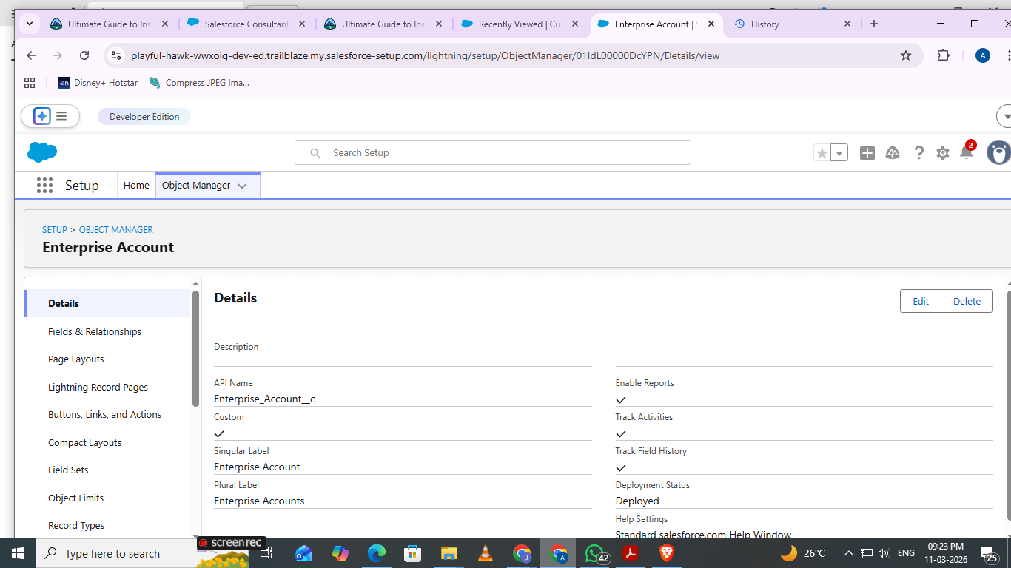

- Customer Account

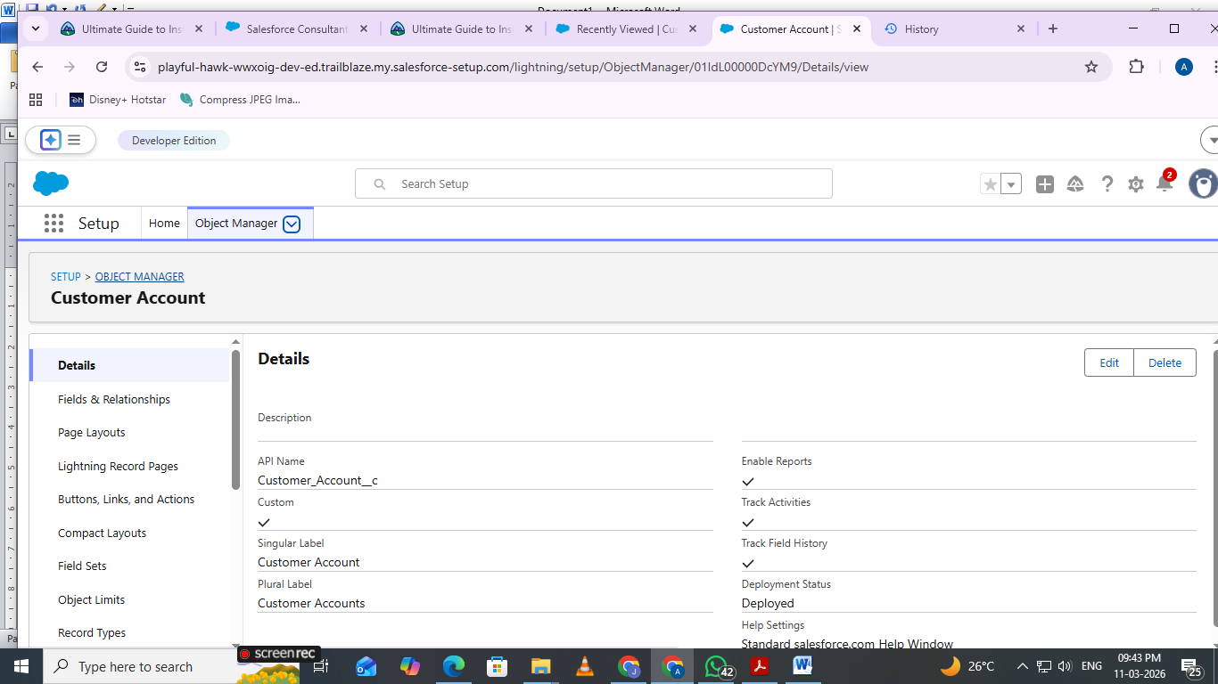

3 Employee Account
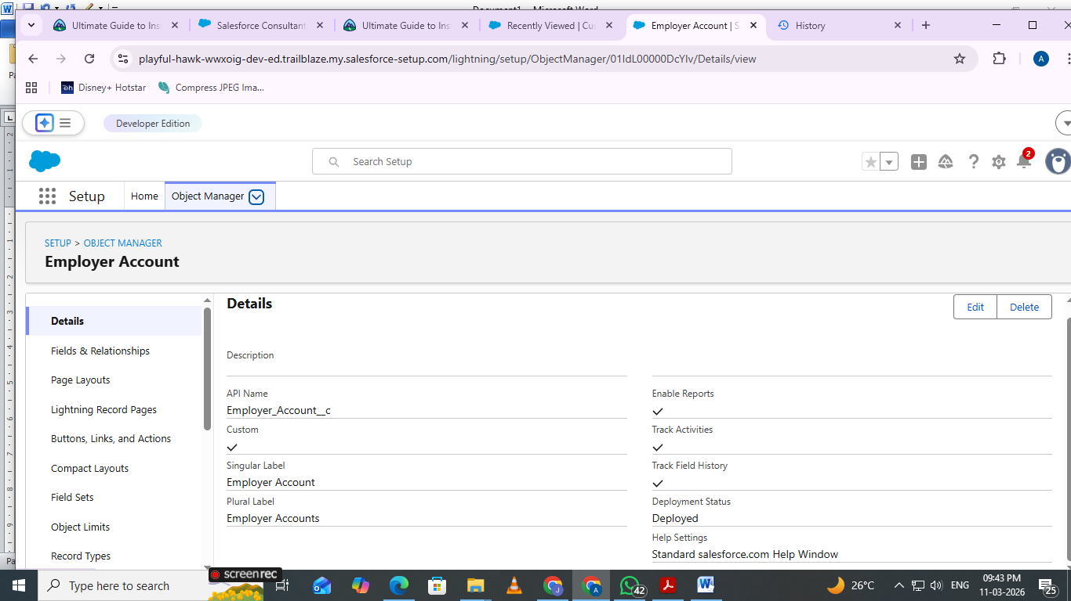

Tabs
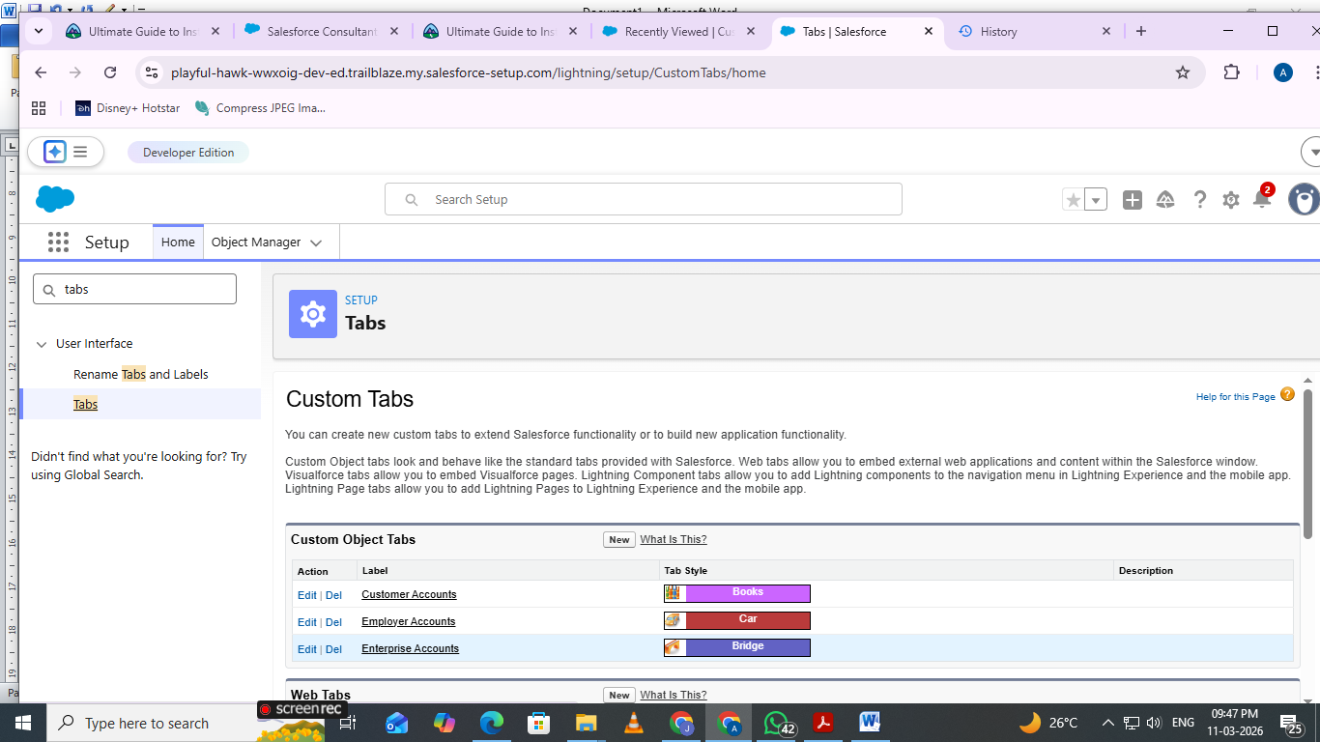
5 App Setting
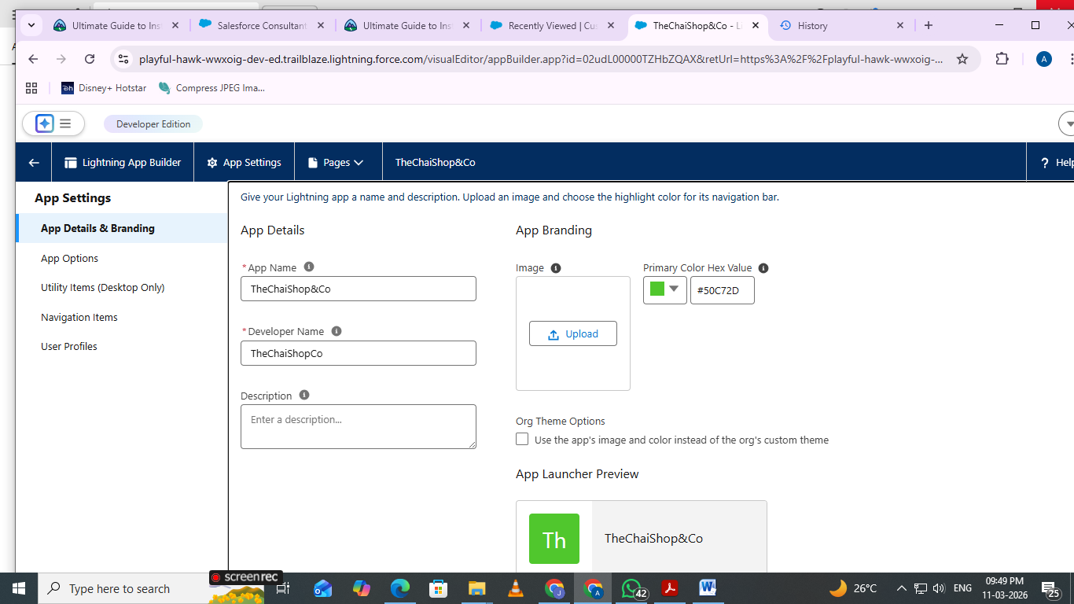
6 Navigation Items

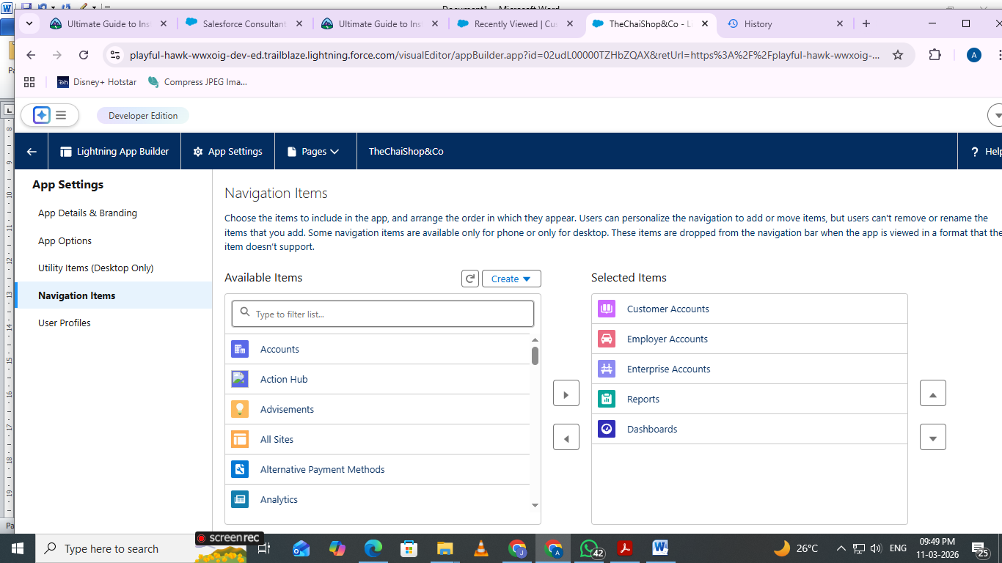

Fields and Relationship

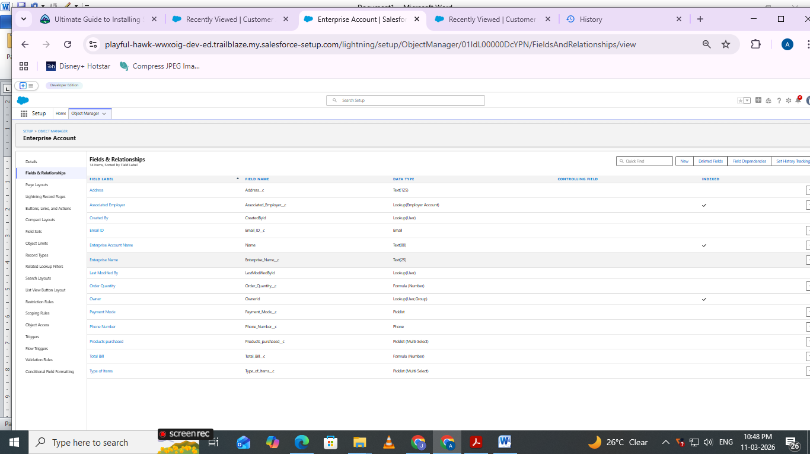

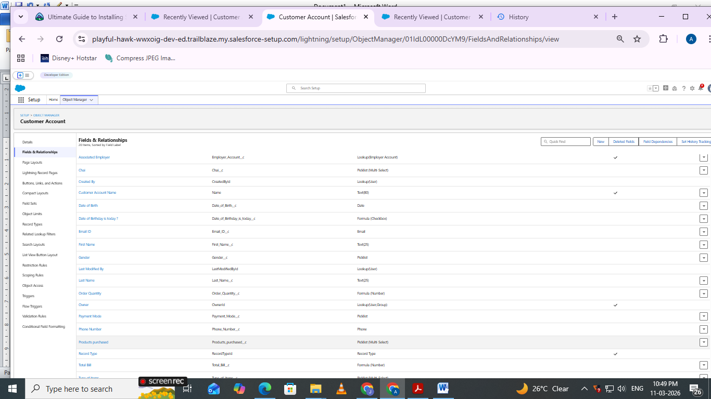

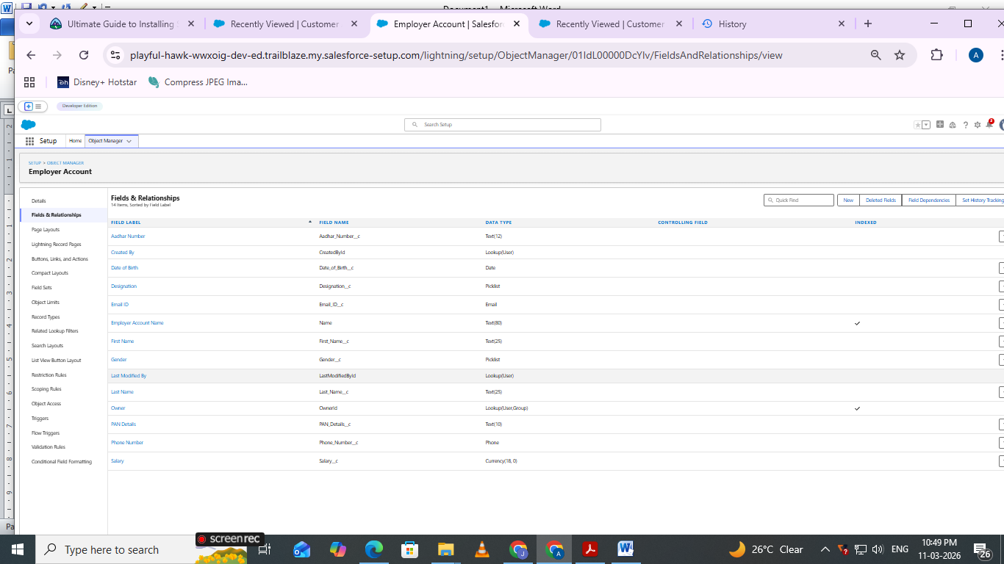
7 Page Layouts
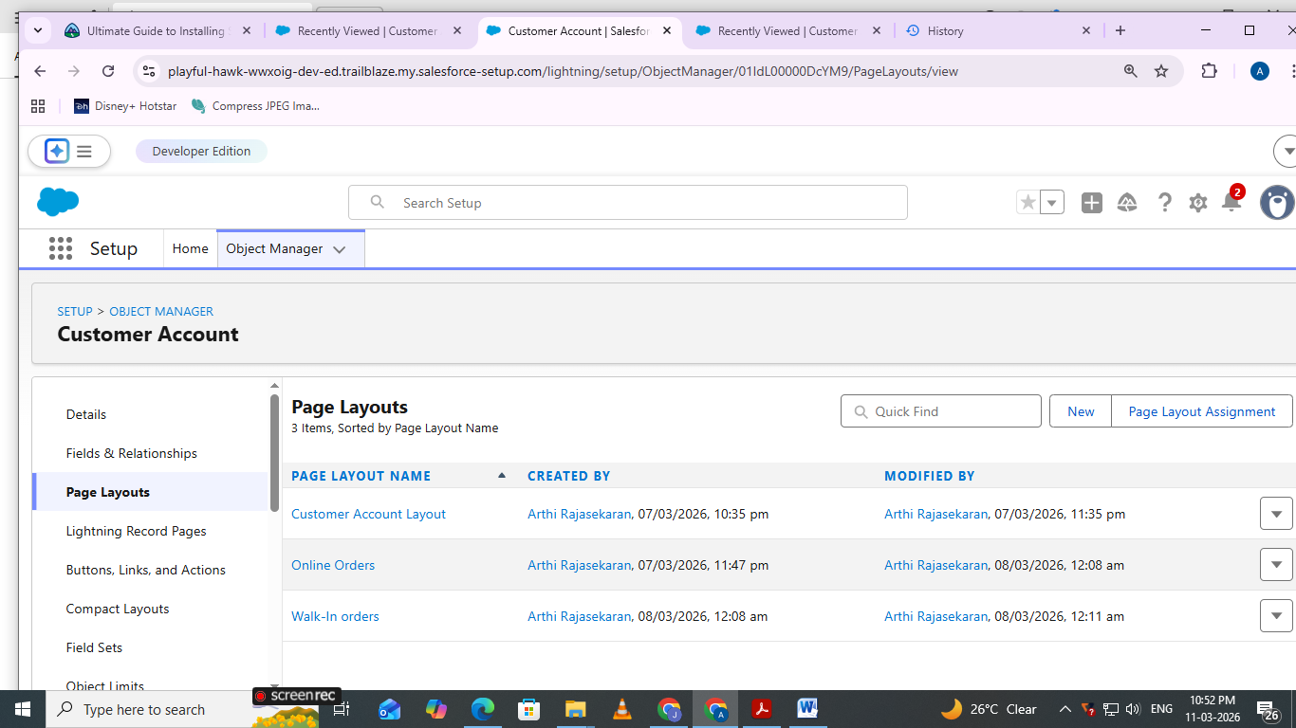
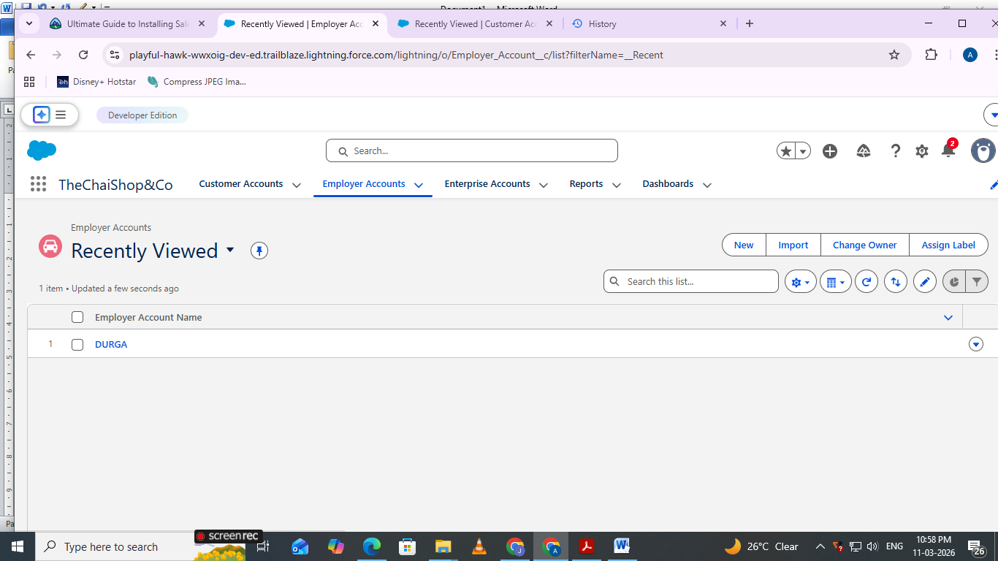

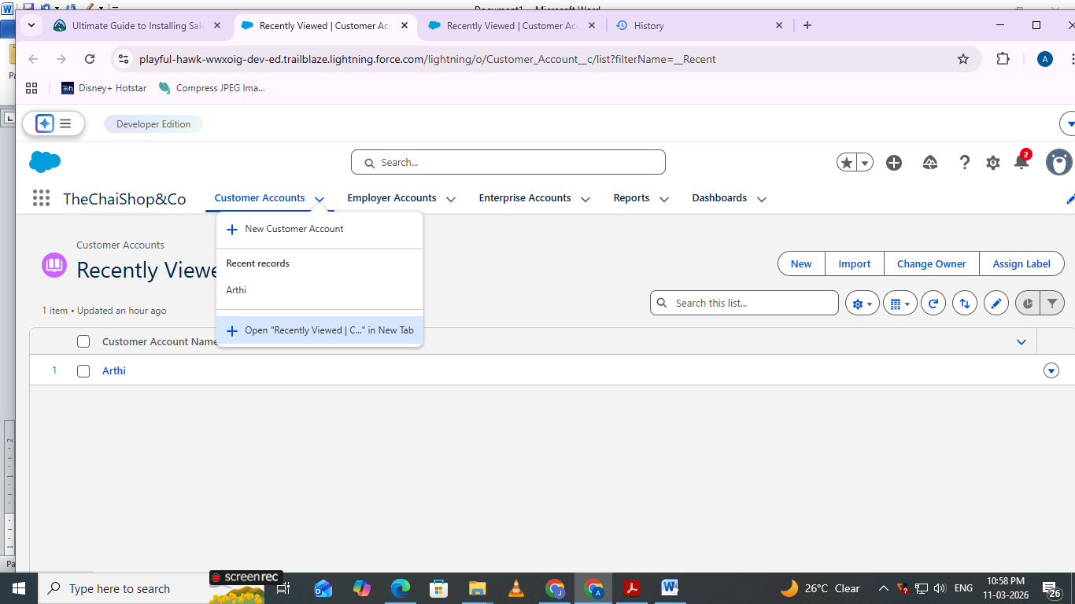
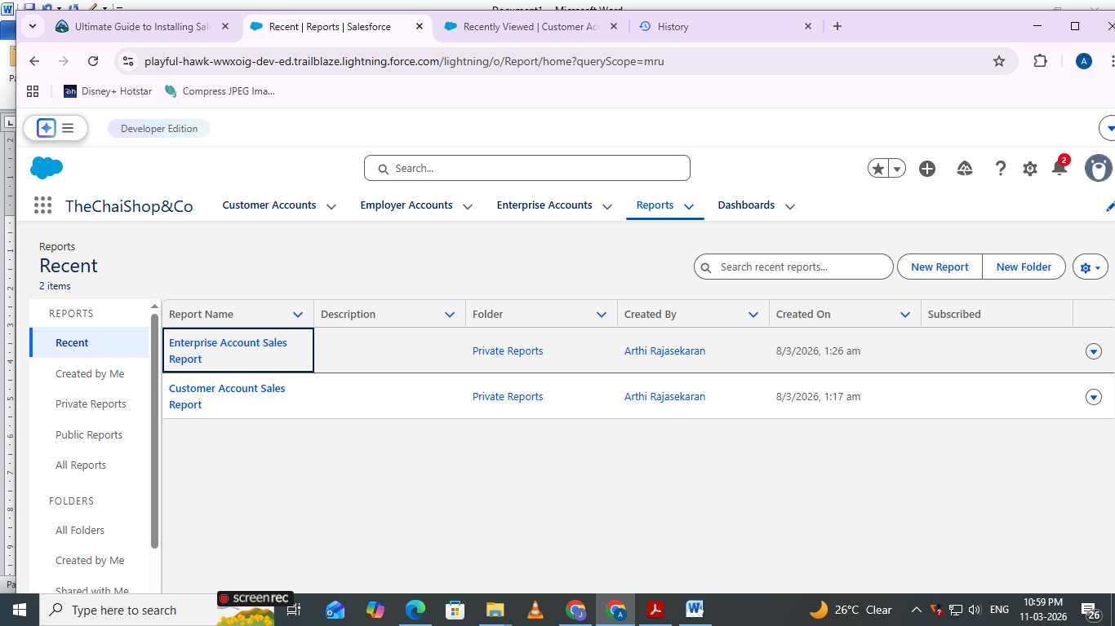

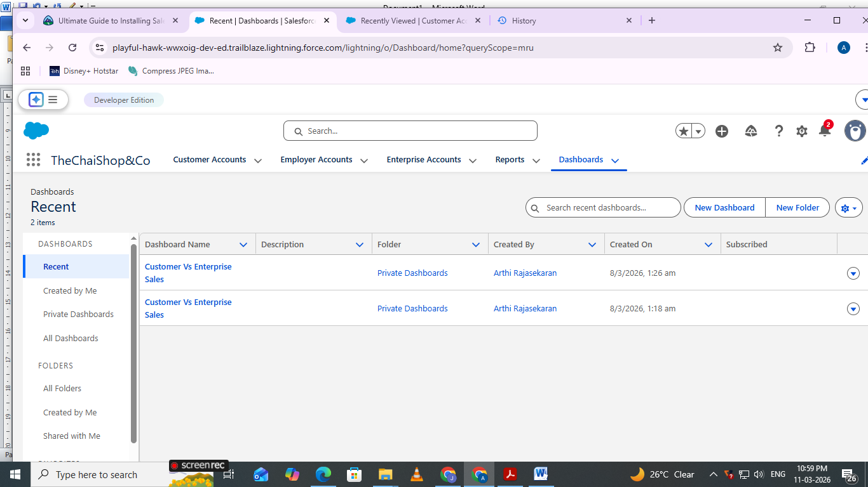

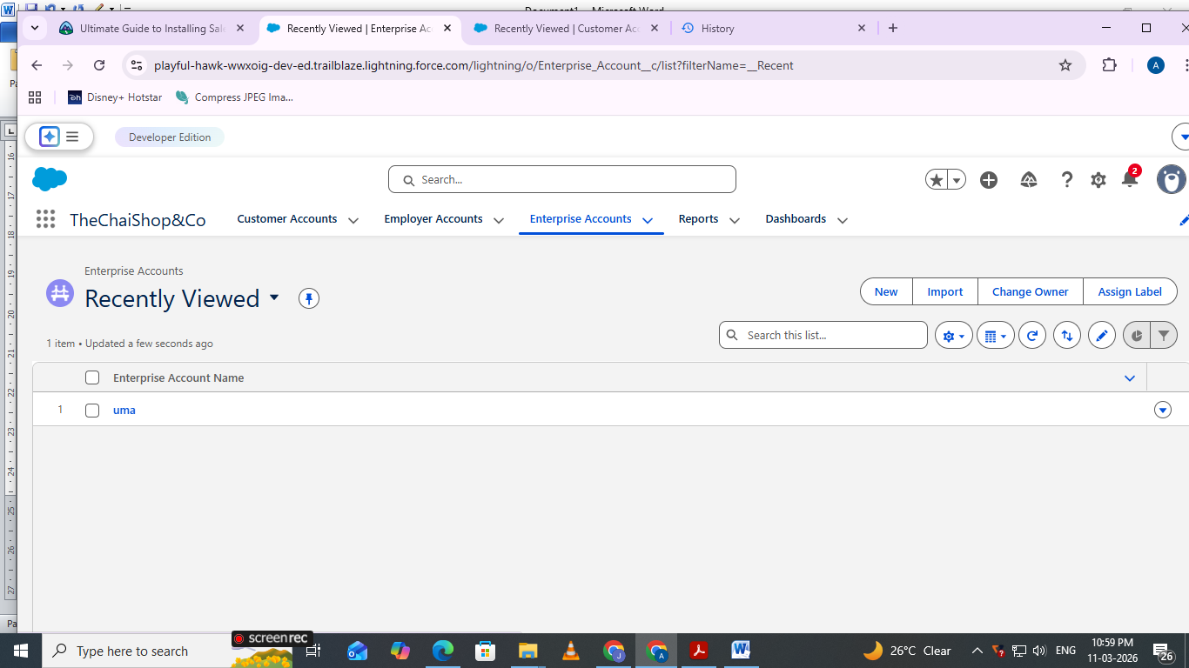

Conclusion:

The CRM Application for TheChaiShop&Co successfully improves business operations by integrating customer data, automating billing, and enabling intelligent reporting. The system reduces errors, saves time, and enhances customer relationships through automation and analytics.

FUTURE SCOPE
  - Mobile CRM integration
  - AI-based sales prediction
  - WhatsApp/SMS alerts
  - Inventory management
  - Multi-branch support
  - Advanced customer profiling
APPENDIX
Source Code : Salesforce Configuration & Flows

Dataset : Customer and Sales Records

Tools Used : Salesforce Developer Org

Thank You

